­­

VMware Horizon on Nutanix

Reference Architecture

v1.0 – February 2013

SE vCenter Deployment on Nutanix

Requirements & How-To Instructions

### Requirements

To run the SE Team’s PowerShell scripts for vCenter deployment you’ll need the following things.

Note: This script has been tested with the VMware vSphere Appliance. It will require modification before use with Windows-based vCenter servers.

1. A Windows PC (can be a VM)
2. The latest version of Microsoft PowerShell
3. The latest version of VMware vSphere PowerCLI
4. The VMware vCenter Appliance OVF (this script has been tested with the vSphere Server Appliance version 5.5.0.20200-2183109 OVF)
5. deployvcenter.ps1 – This script will deploy the vCenter OVF (download [here](https://github.com/digitalformula/public-scripts/blob/master/nutanix/deployvcenter.ps1))
6. configurevCenterOnly.ps1 – This script will configure the vSphere Appliance as per Nutanix best practices (download [here](https://github.com/digitalformula/public-scripts/blob/master/nutanix/configurevCenterOnly.ps1))

For the Windows components it is recommend to run Windows Update and apply all updates, including PowerShell updates if any are available.

### Assumptions

1. The scripts and OVF files above have already been copied to or are available on the Windows PC you intend to use.
2. The vCenter Appliance has an IP address and that you can access that IP address via SSH.
3. You’ve accepted the EULA. To complete the EULA steps, SSH to the vCenter Appliance and run the following (all on one line).

*/usr/sbin/vpxd_servicecfg eula accept; /usr/sbin/vpxd_servicecfg db write embedded; /usr/sbin/vpxd_servicecfg sso write embedded; /usr/sbin/vpxd_servicecfg service start*

Note that this is a basic configuration that may not work for full production environments (it assumes use of the embedded database type). Changes are required for use with other database types.

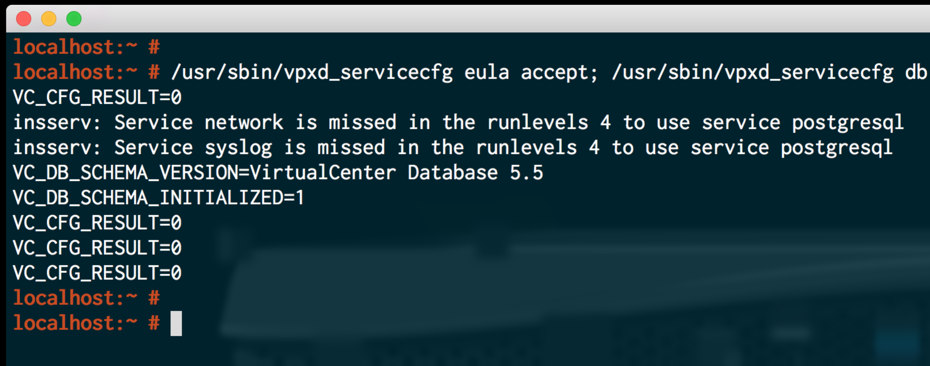

1. The vSphere Cluster exists
2. The ESX hosts are already part of the vSphere Cluster. There is also a script that configures everything, including adding the hosts. However, it is intended for demo/testing environments only and is outside the scope of this document.
3. All the CVMs have “CVM” somewhere in the name … and no other VMs do!

### Step 1 – Configure deployment script variables

This needs to be done before the scripts are run for the first time. In the deployvcenter.ps1 script, set the following variables to match your environment.

* $esxHost: The IP address of the host you’ll deploy the OVF to
* $esxUser: The username that will allow administrative login to the ESX host
* $esxPassword: The password for the $esxUser account
* $datastoreName: The name of the ESX datastore (Nutanix container) that will hold the vSphere Appliance
* $vAppFilename: The full path to the OVF for deployment
* $vAppName: The name that will be given to the vSphere Appliance (i.e. the VM name)

### Step 2 – Run the deployment script

At this point you can just run deployvcenter.ps1 and let the script do the rest.

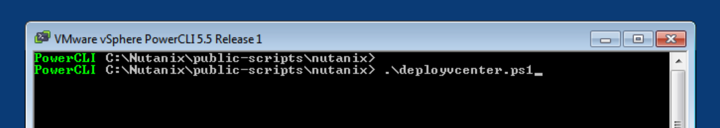

Fig 1. Run the deployvcenter.ps1 script

### Step 3 – Configure vCenter script variables

This script has a few configuration options, all of which you’ll need to set at least once.

* $viServer: The IP address of vCenter Appliance
* $viUser: The username that will allow administrative login to the vSphere Appliance
* $viPassword: The password for the $viUser account
* $clusterName: The name of the existing vSphere Cluster that will be configured
* $HACPUPercent: The percentage of cluster CPU to reserve as failover spare capacity – **configure this properly!**
* $HAMemPercent: The percentage of cluster RAM to reserve as failover spare capacity – **configure this properly!**
* $advancedSettings array: Any settings that exist here will all be set to true. For example, Nutanix Best Practice suggests setting das.ignoreInsufficientHbDatastore to true to avoid warnings in single-datastore environments. If you have a good reason to not set any advanced settings here, leave the array empty, like this:

*$advancedSettings = @()*

### Step 4 – Run the configuration script

At this point you can just run deployvCenterOnly.ps1 and let the script do the rest.

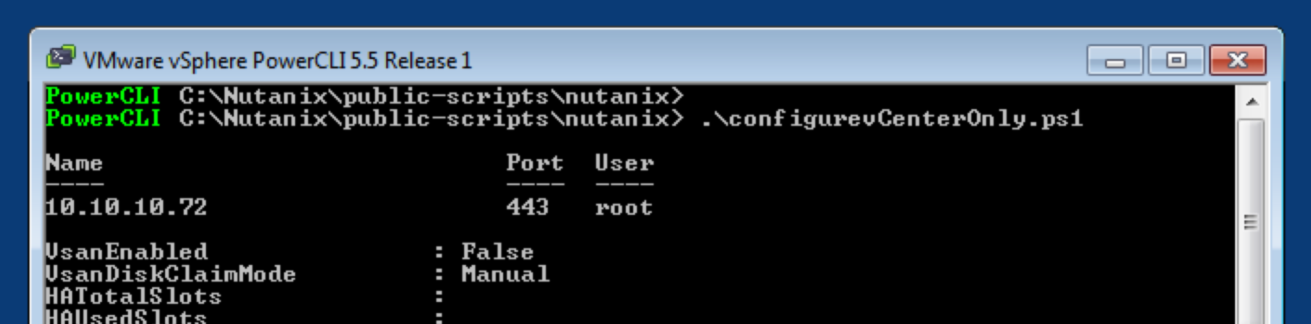

Fig 2. Run the configurevCenterOnly.ps1 script

If you want to check that everything has worked afterwards, login to the vSphere Client (Windows) or the vSphere Web Client and look at the properties of the cluster.

For example:

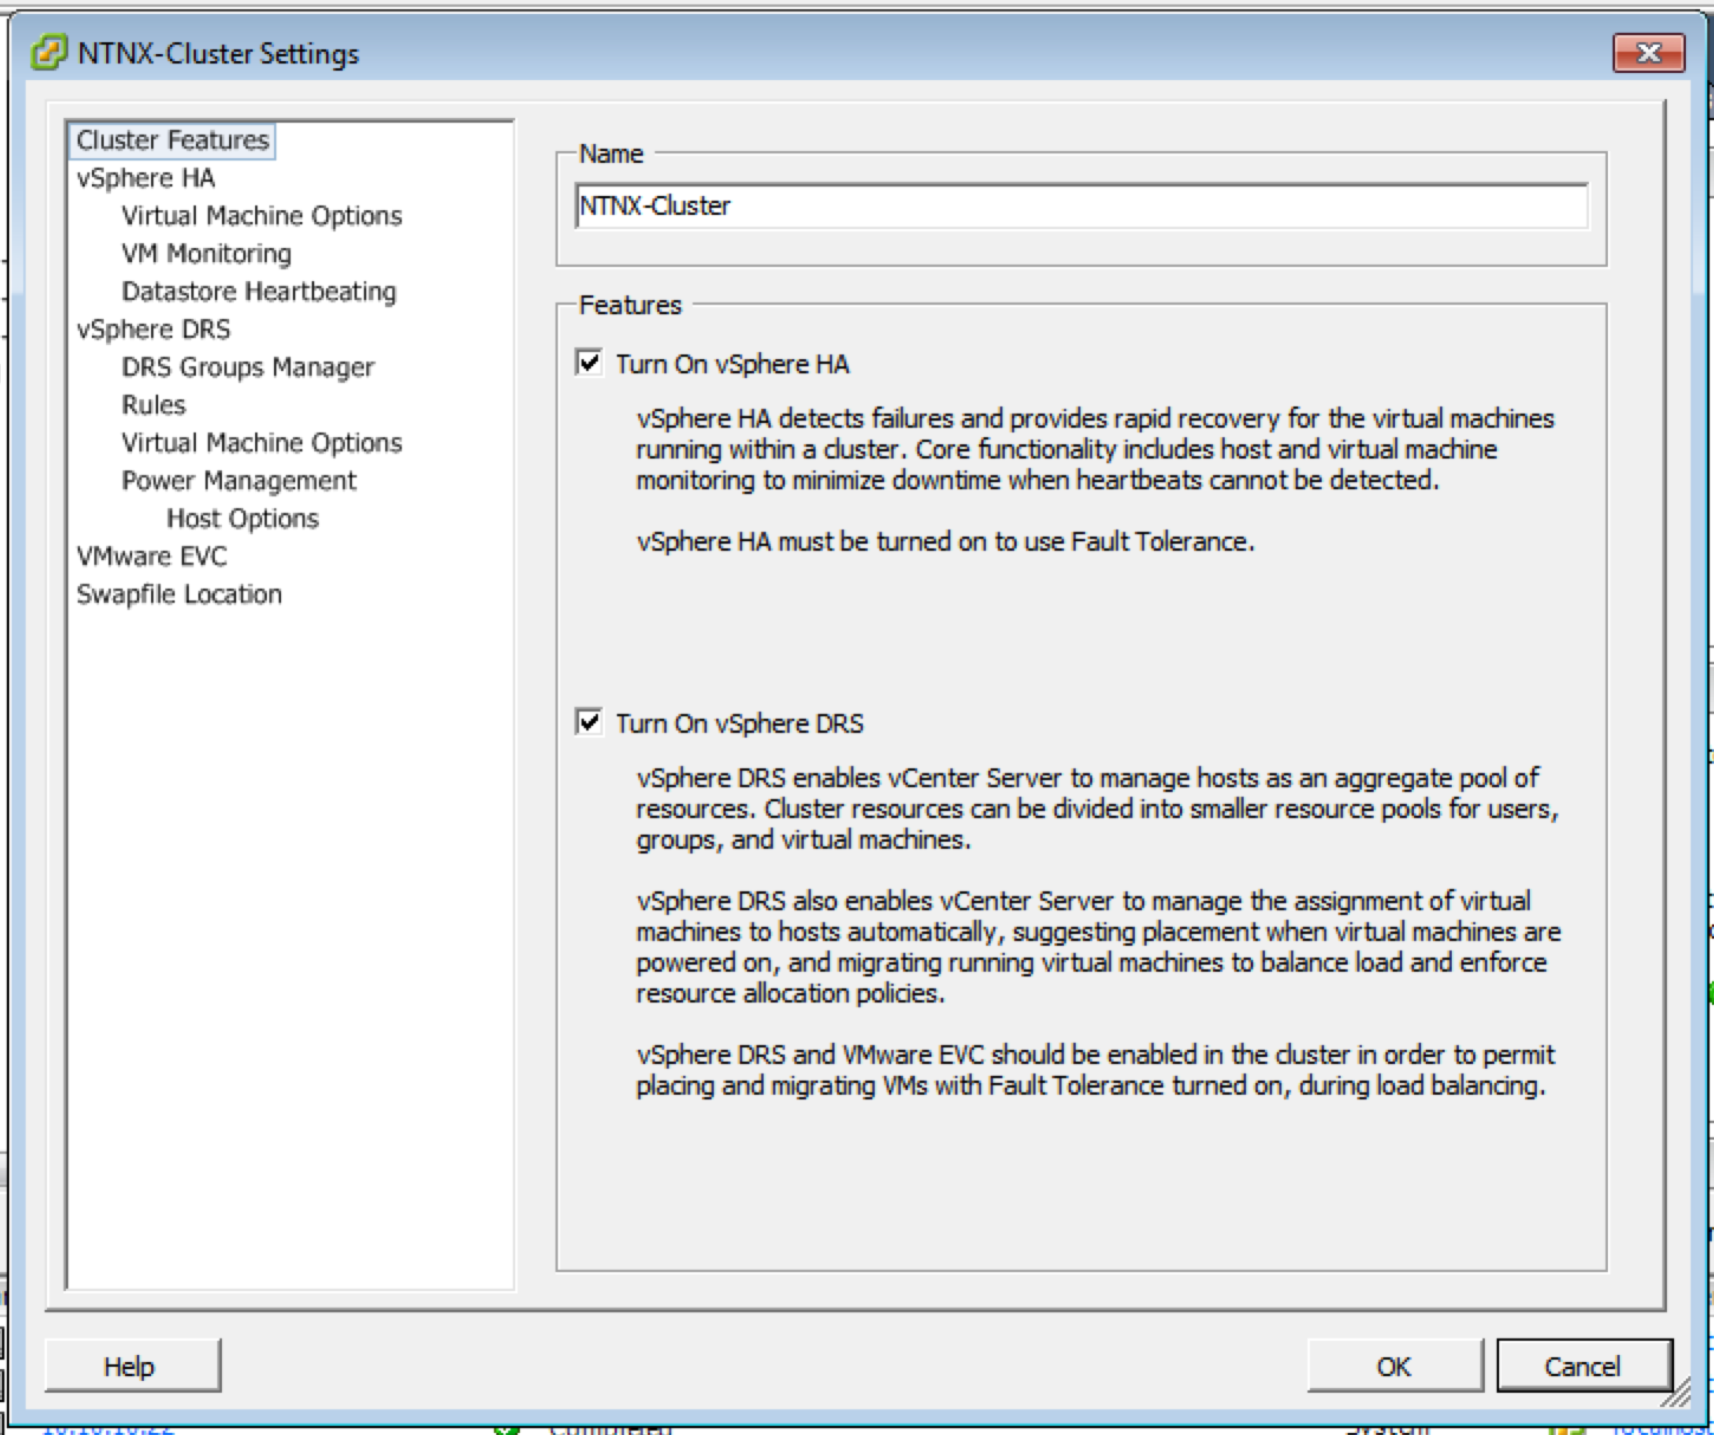

Fig 3. Cluster configuration after running configurevCenterOnly.ps1 (Windows vSphere Client)

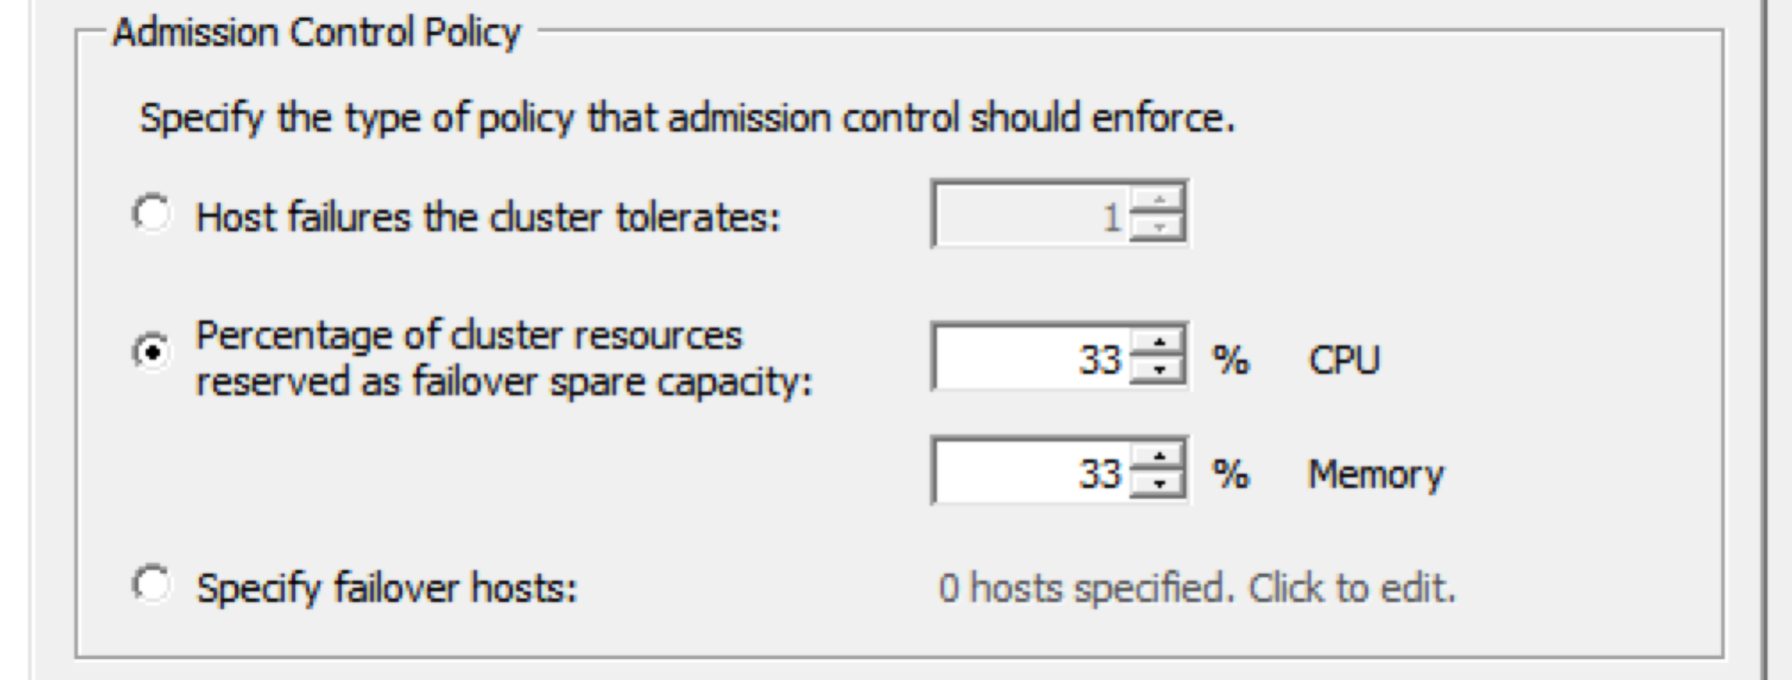

Fig 4. Admission Control Policy after running configurevCenterOnly.ps1 (Windows vSphere Client)

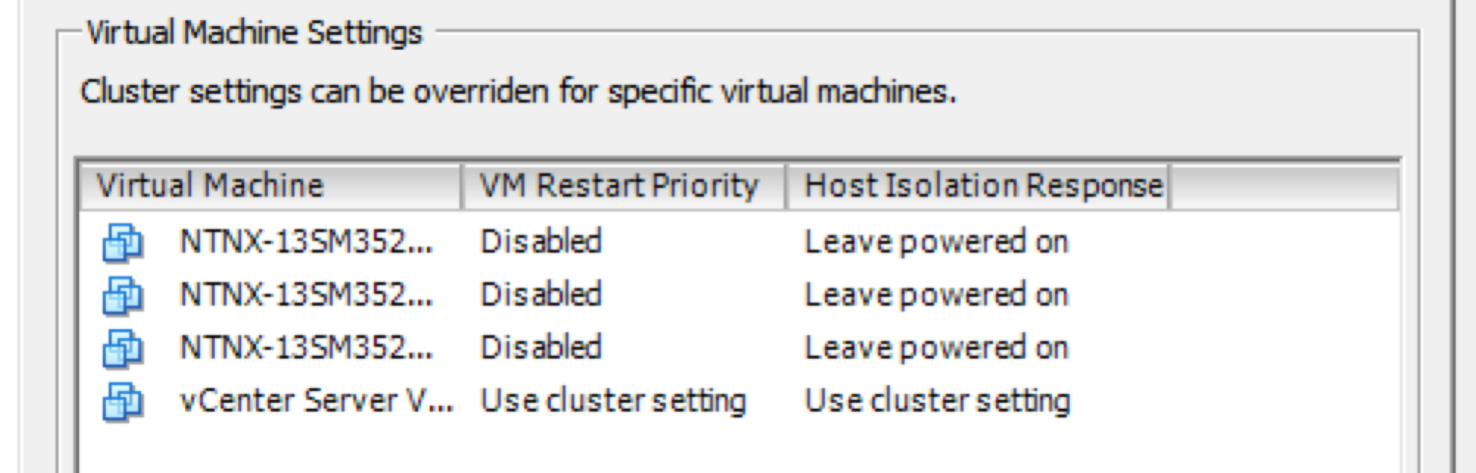

Fig 5. CVMs configured as per Nutanix best practices (Windows vSphere Client)